
Name & Department
Mark Forster
Sales Department (New York)
mark.forster@apple.com

Fun Check-In [Name]
Date: 5th September 20XX

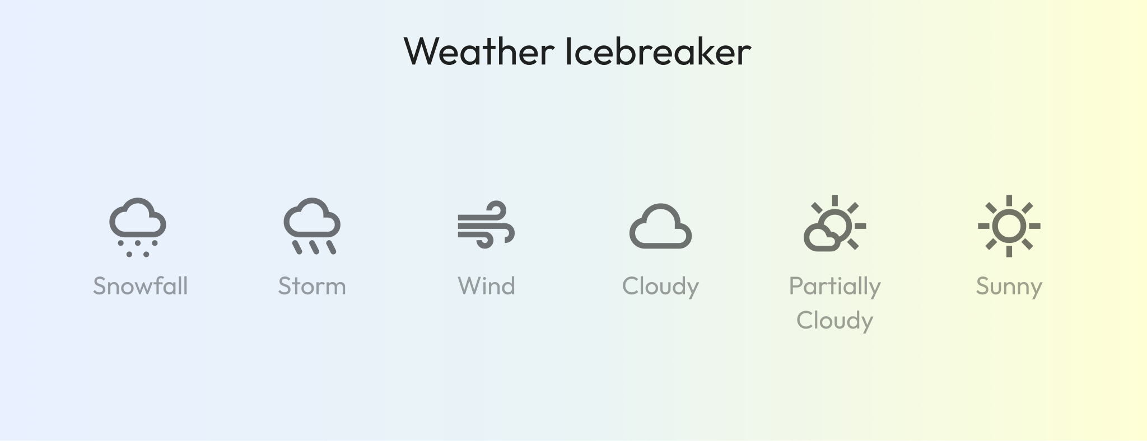
- Have a look at the image above: What is the weather like for you at the moment…
  - …in your current Project?
  - …in your job overall?
  - …privately?

TOPICS DIRECT REPORT (Name)
- …

MANAGER'S TOPICS: DEEP DIVE
- What has inspired you recently?

- What did you learn recently?

- If you were the CEO of this company, what would you do?

- If you could change one thing about our meetings & routines, what would it be?

- What could we try to bring fresh ideas into our work?

CLOSING
- I really appreciate your honesty.
- What is your main takeaway from today’s Check-In?

